**Welcome Screen:**

This Is the welcome screen in which it has a button (pick a photo). By clicking it , opens the options for camera or from gallery.

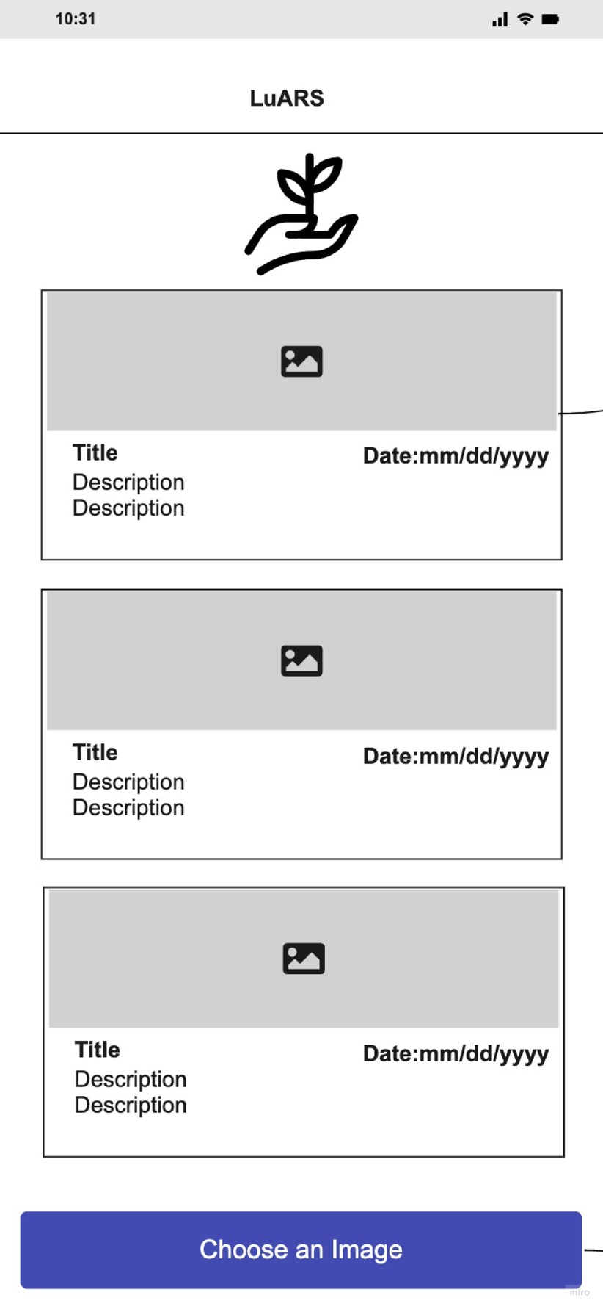

**Image Upload Screen:**

Once the image is selected we can edit the image and click get result button to generate results about crop health.

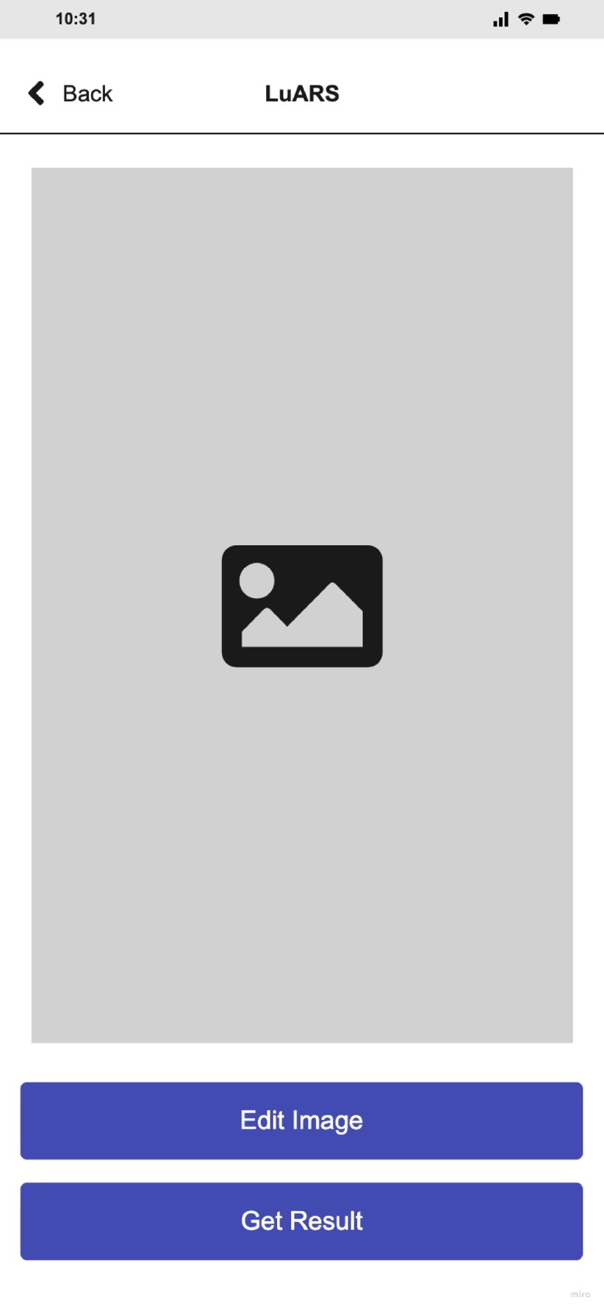

**ResultScreen:**

In result screen, the results will be displayed whether the crop is healthy or not. If healthy if give few set of instructions and if unhealthy it recommends the instructions to be followed and allows to take a picture for disease identification.

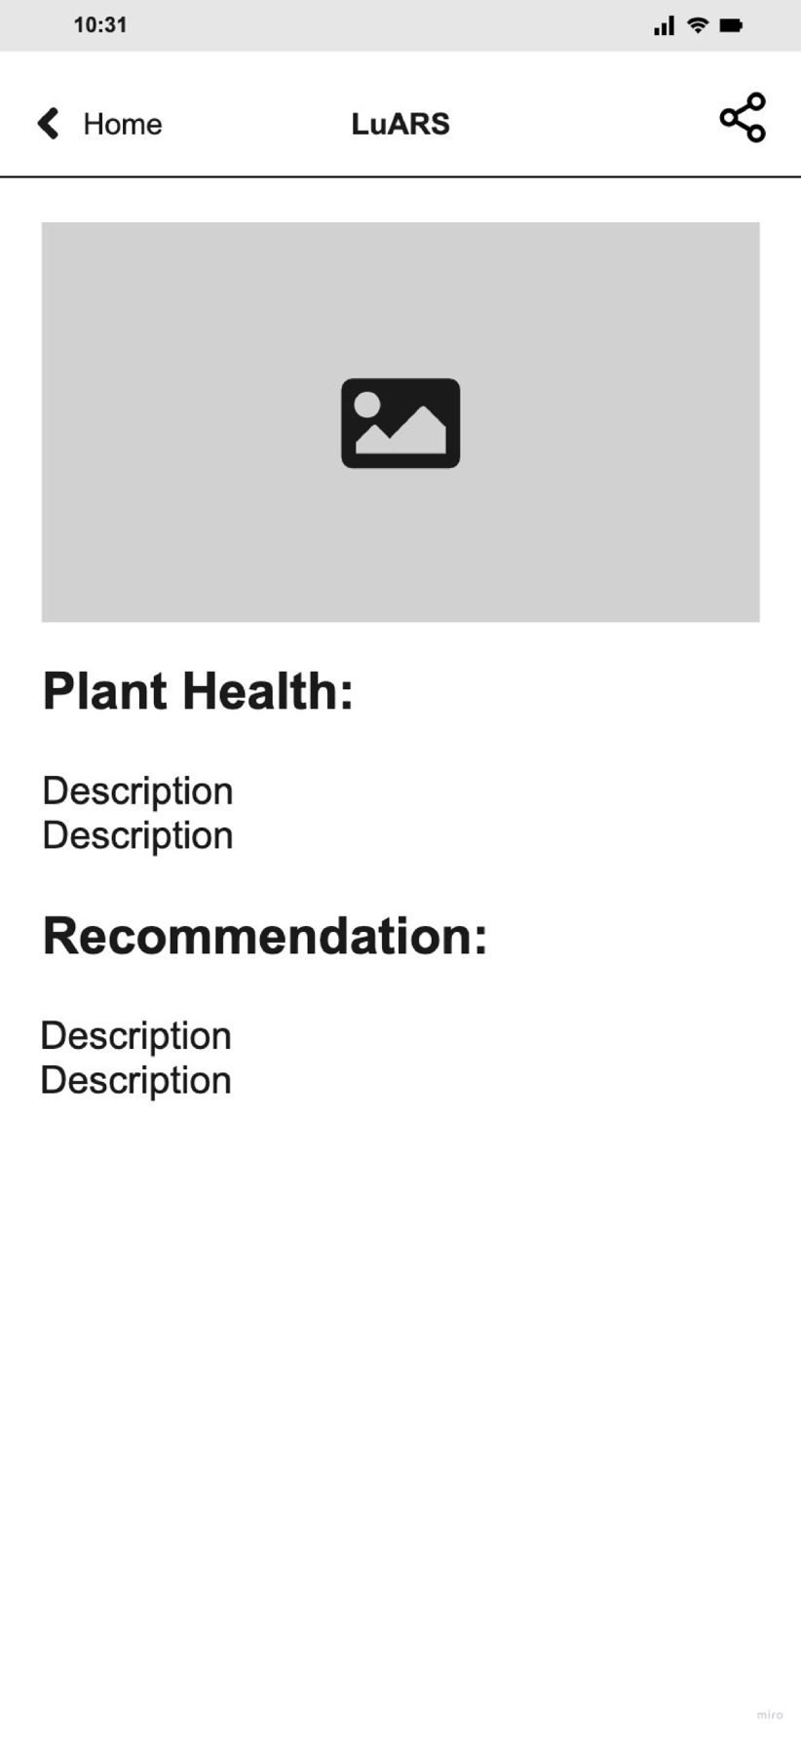

**ResultScreen:**

